User Email Add/Delete/Edit
Add

1. Select Promo Pin under the tools menu
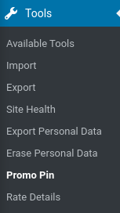

2. Click Add a Promo Pin to add in a new email and pin number
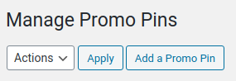

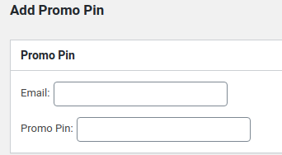

Delete
1. Click delete under email you would like to remove in the main table
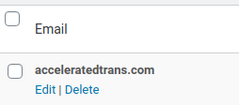

Edit
1. Click edit under email you would like to change in the main table
2. Edit the values and click Edit Promo Pin to save the changes
